Engineering Surface Traces for Self-Propulsion of Droplets

Vi-Vie Ng,¹ Volker Nock,² Mathieu Sellier¹

¹ Department of Mechanical Engineering, University of Canterbury, Christchurch 8041, New Zealand, vivienne.ng@pg.canterbury.ac.nz
² Department of Electrical and Computer Engineering, University of Canterbury, Christchurch 8041, New Zealand

Self-propulsion of droplets may facilitate automated synthesis and analysis of small liquid samples in lab-on-a-chip applications¹. Building upon previous work by our group², this research aims to improve the mechanism of self-propulsion by means of prolonging the hydrophilicity of polydimethylsiloxane (PDMS) surface traces, as well as investigate the geometrical limits of trace patterning. To engineer a more sustainable hydrophilic surface, we investigated the grafting of polyvinylpyrrolidone (PVP) on plasma-activated PDMS traces. Our findings show a sustained hydrophilicity for >10 days with PVP. However, self-propulsion for a 1 mm treated channel was observed only on the same day as treatment. Using these optimized conditions we show propulsion of droplets up an incline and discuss how this can be used to determine the propulsion energy.
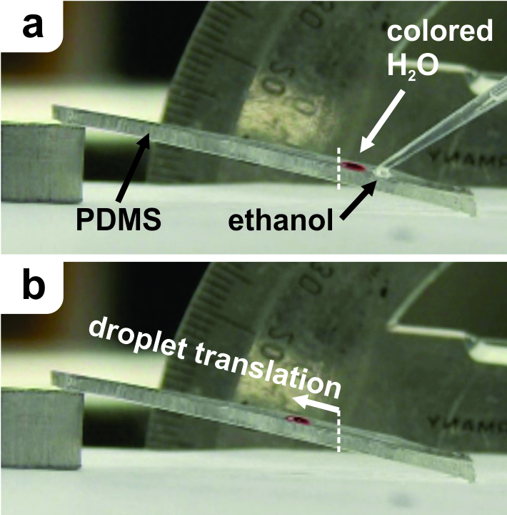
Figure 1 Guided droplet propulsion up a PDMS incline. a) Deposition of water and ethanol droplets and b) translated water droplet.

References:
¹ Darhuber, A.A., Troian, S.M., 2005. Principles of microfluidic actuation by modulation of surface stresses. Annu. Rev. Fluid Mech. 37, 425–455.
² Sellier, M., Nock, V., Gaubert, C., Verdier, C., 2013. Droplet actuation induced by coalescence: Experimental evidences and phenomenological modelling. Euro. Phys. J. Spec. Top. 219: 131-141.

